Creating RR pair with Command line utility

Steps to be followed:

1. Create Virtual Service using RR Pairs in Workstaion
2. After the image is created, click Save Image of the Save icon above the Finish button, then click Finish.

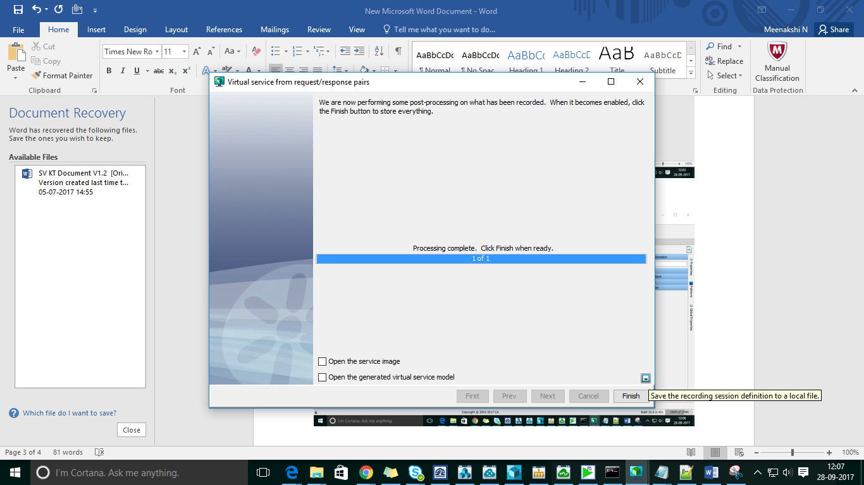

The settings are saved in a file with a RR1**.vrs** extension.

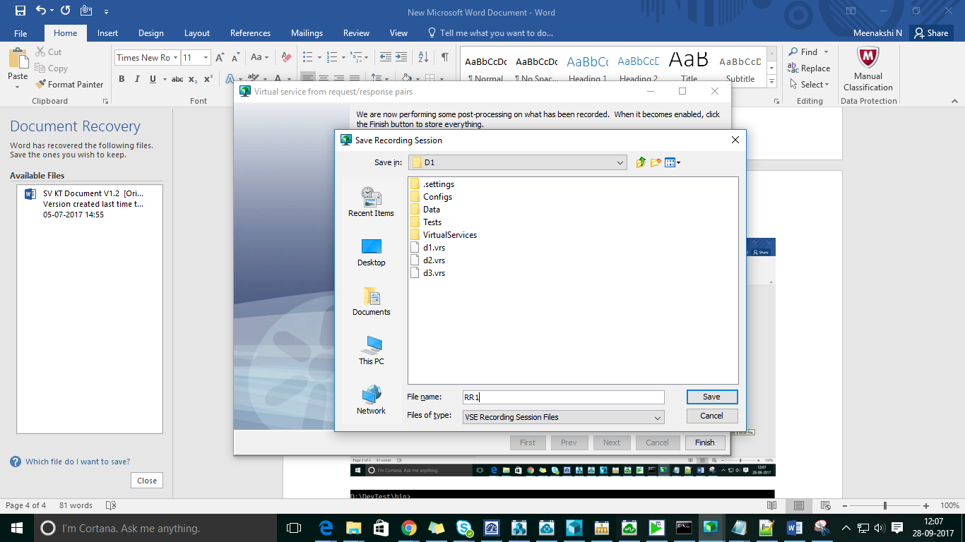

Click on Finish.

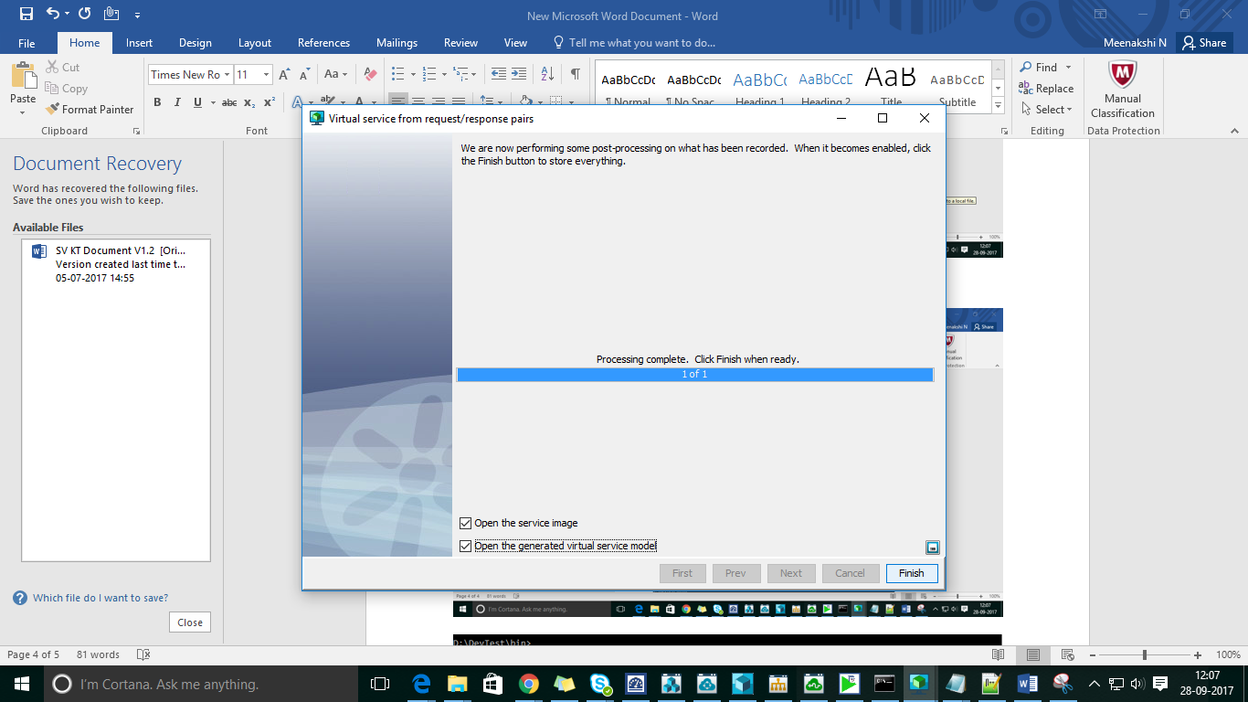

Navigate to the Devtest_HOME\bin directory and enter the following command:

**Command**: ServiceImageManager.exe --vrs=PathToTheVrsFile --si-file=PathToTheVsiFile --vsm-file=PathToTheVsmFile --record –go

D:\DevTest\bin>ServiceImageManager.exe --vrs=D:\DevTest\Projects\D1\RR1.vrs --si-file=D:\DevTest\Projects\D1\VirtualServices\Images\RR1.vsi --vsm-file=D:\DevTest\Projects\D1\VirtualServices\RR1.vsm --record --go

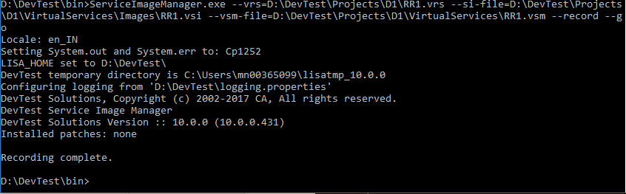

The VRS file saved with the configuration is below:

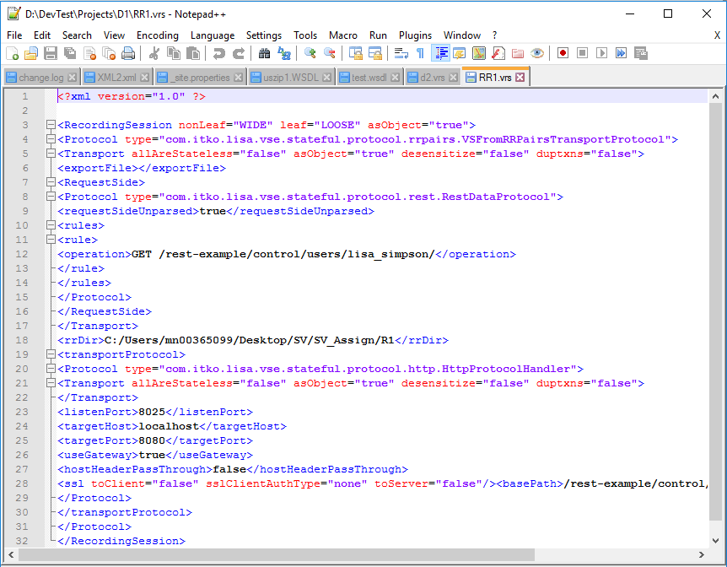

We can use the same VRS file to create new virtual services or make changes according to your requirement and create virtual services. In this VRS file , have changed to new RR pairs and PORT.

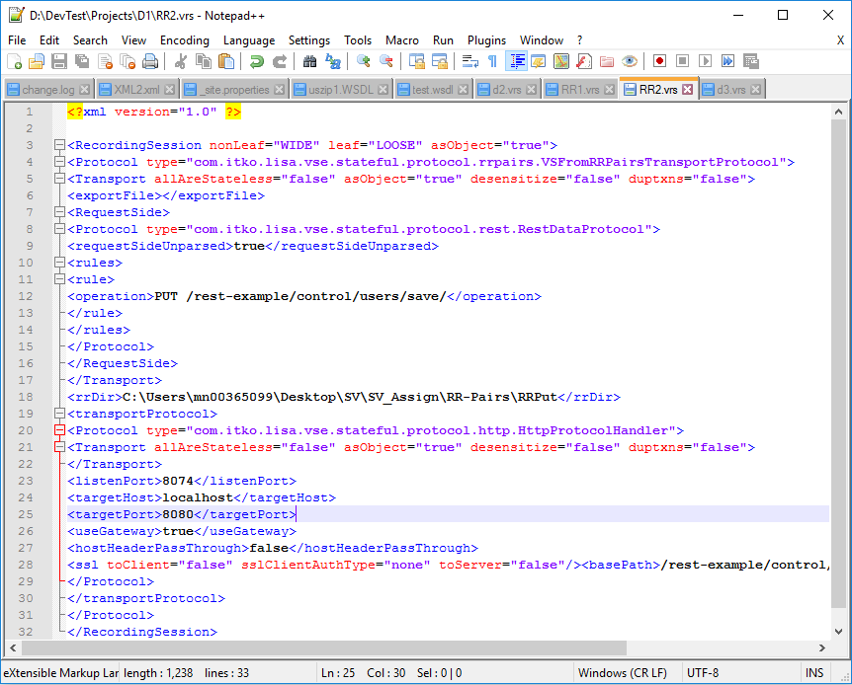

Navigate to Devtest_Home/bin

ServiceImageManager.exe --vrs=D:\DevTest\Projects\D1\RR2.vrs –si file=D:\DevTest\Projects\D1\VirtualServices\Images\RR2.vsi --vsm-file=D:\DevTest\Projects\D1\VirtualServices\RR2.vsm --record --go

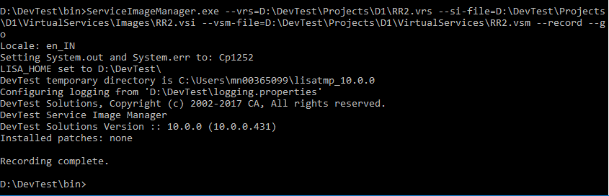

Now go and check in Workstation you can find a new VSI and VSM created.

